**320 N. LOCUST STREET POINT, TEXAS 75472 PH:903-598-3296 FAX:903-598-3371**

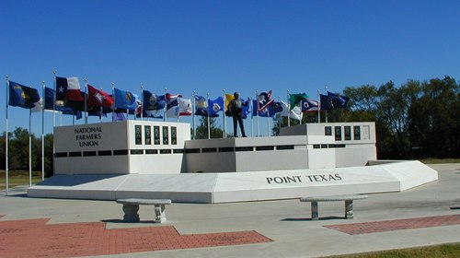**CITY OF POINT**

**Email: cityclerk@cityofpoint.org**

**CERTIFICATE OF OCCUPANCY APPLICATION**

Date:________________________

Tax ID#:_________________________Phone:_____________________________

Address:____________________________________________________________

Owner:_____________________________________________________________

DBA:_______________________________________________________________

Business Use: Retail_____Wholesale_____MFG_____Church_____Service_____

Restaurant_____On-site Food Prep_____

Describe Business____________________________________________________

Total Employees_____ Hours of Operation________ to_______

Is the building equipped with automatic fire sprinkler? **Y N**

Manual or Automatic Alarm System?___________

Area sq. ft.: Office_______Warehouse_______Retail_______Restaurant_______

Mfg.________Sanctuary________Other_______Total_______

Number of sq. ft. used for storage over 12’ in height_______

**ALL FOOD ESTABLISHMENTS MUST PROMINENTLY DISPLAY THEIR STATE OF TEXAS HEALTH CERTIFICATE.**

I hereby certify that I have read and examined this application and know the same to be true and correct. All provisions of laws and ordinances governing this type of work will be complied with whether specified herein or not. The granting of a permit does not presume to give authority to violate or cancel the provisions of any state or local law regulating construction or the performance of construction. The issuance of a building permit neither exempts nor modifies any covenants, deed restrictions, city ordinances and/or federal laws, whether herein specified or not.

**All sections must be filled out completely.**

**Applicant Printed Name___________________________________Signature_______________________________**

**Phone___________________________Email_________________________________________________________**

**Reviewed By Printed Name_____________________Signature__________________________**

**Approved/Denied Date:_____________________**

**IF DENIED YOU MUST REAPPLY WITH A NEW APPLICATION.**

**Comments:__________________________________________________________________________________________________________________________________________________**