**320 N. LOCUST STREET POINT, TEXAS 75472 PH:903-598-3296 FAX:903-598-3371**

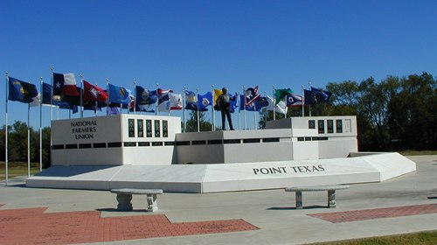**CITY OF POINT**

**Email: cityclerk@cityofpoint.org**

**Contractor/Trade Registration**

Name_________________________________________Date____________________________

Service Address_________________________________________________________________

City___________________________________________State___________________________

Email__________________________________________Phone__________________________

Company_______________________________________Address_________________________

Electrical______________________Fire Suppression & Extinguisher_______________________

Mechanical_____________________________Plumbing________________________________

**Master Registration**

Name_________________________________________Date____________________________

Company Address_______________________________________________________________

City___________________________________________State___________________________

Email__________________________________________Phone__________________________

State Electrical License____________________________*

State HVAC License_______________________________*

State Plumbing License____________________________

**\*Fees:( $110.00 ea)________________________________**

**Payment Type:_____CASH_____CHECK_____MO_____CREDIT CARD**

**Received By:_____________________________________Date:__________________________**